Joe Merrill
13 MAR 2026
CMSC 451 Homework 4

Graph used in all four problems

Vertices:
A, B, C, D, E, F, G, H, I, J, K

Directed edges:
A->B
A->C
B->E
B->G
C->B
C->D
C->F
D->H
E->G
E->H
E->J
E->K
F->C
G->A
H->I
I->D
K->J

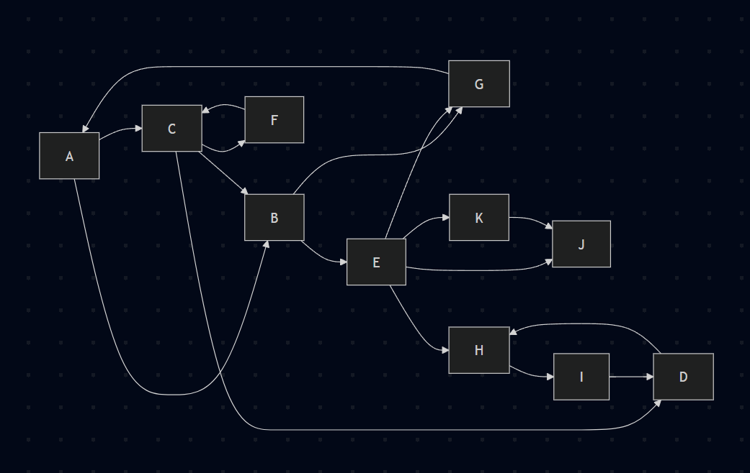

Adjacency lists in alphabetical order:

A: B, C
B: E, G
C: B, D, F
D: H
E: G, H, J, K
F: C
G: A
H: I
I: D
J:
K: J

1. Breadth-first search

Using alphabetical vertex order, BFS starts at A.

Visit order:
A, B, C, E, G, D, F, H, J, K, I

Breadth-first search tree edges:
A->B
A->C
B->E
B->G
C->D
C->F
E->H
E->J
E->K
H->I

Breadth-first search tree:

A
|-- B
| |-- E
| | |-- H
| | | `-- I
| | |-- J
| | `-- K
| `-- G
`-- C
|-- D
`-- F

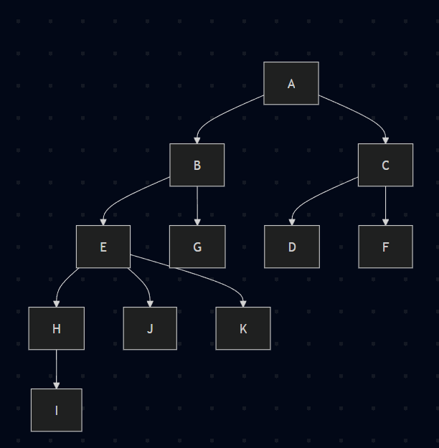

Levels:
Level 0: A
Level 1: B, C
Level 2: E, G, D, F
Level 3: H, J, K
Level 4: I

2. Depth-first search

Using alphabetical order for both the vertices and the adjacency lists, DFS begins at A and reaches every vertex.

Start/finish times:
A: 1/22
B: 2/17
E: 3/16
G: 4/5
H: 6/11
I: 7/10
D: 8/9
J: 12/13
K: 14/15
C: 18/21
F: 19/20

DFS tree edges:
A->B
B->E
E->G
E->H
H->I
I->D
E->J
E->K
A->C
C->F

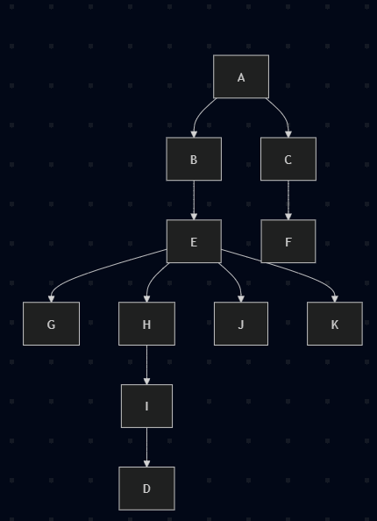

Edge classification:
A->B: tree
A->C: tree
B->E: tree
B->G: forward
C->B: cross
C->D: cross
C->F: tree
D->H: back
E->G: tree
E->H: tree
E->J: tree
E->K: tree
F->C: back
G->A: back
H->I: tree
I->D: tree
K->J: cross

3. Remove all back edges, then produce topological orders

Back edges from part 2:
D->H
F->C
G->A

Removing those three edges makes the graph a DAG.

DAG adjacency lists:
A: B, C
B: E, G
C: B, D, F
D:
E: G, H, J, K
F:
G:
H: I
I: D
J:
K: J

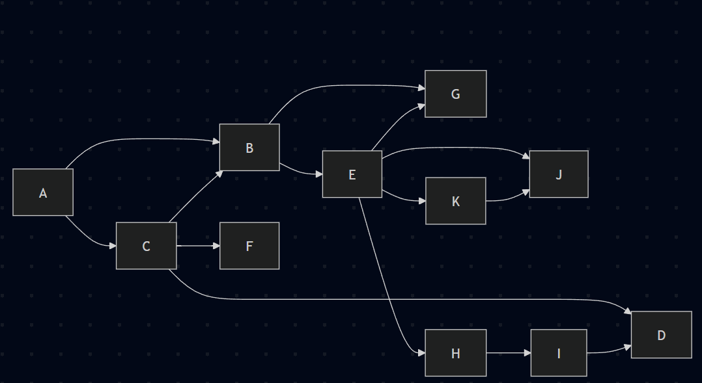

Depth-first search on the DAG gives these start/finish times:
A: 1/22
B: 2/17
E: 3/16
G: 4/5
H: 6/11
I: 7/10
D: 8/9
J: 12/13
K: 14/15
C: 18/21
F: 19/20

Topological order from decreasing finish times:
A, C, F, B, E, K, J, H, I, D, G

One breadth-first topological order:
A, C, B, E, F, G, H, I, D, K, J

4. Strongly connected components

From the first DFS on the original graph, the vertices in decreasing finish-time order are:
A, C, F, B, E, K, J, H, I, D, G

Transpose graph adjacency lists in alphabetical order:
A: G
B: A, C
C: A, F
D: C, I
E: B
F: C
G: B, E
H: D, E
I: H
J: E, K
K: E

Perform DFS on the transpose graph in the decreasing finish-time order above.

Start/finish times on the transpose:
A: 1/12
G: 2/11
B: 3/8
C: 4/7
F: 5/6
E: 9/10
K: 13/14
J: 15/16
H: 17/22
D: 18/21
I: 19/20

Final DFS forest on the transpose:
Tree 1 rooted at A:
A->G
G->B
B->C
C->F
G->E

Tree 2 rooted at K:
K

Tree 3 rooted at J:
J

Tree 4 rooted at H:
H->D
D->I

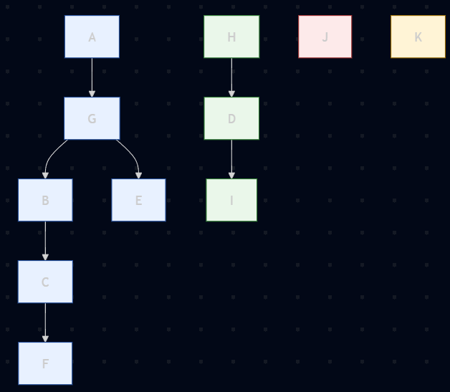

Strongly connected components:
{A, B, C, E, F, G}
{D, H, I}
{K}
{J}

Each DFS tree in the transpose corresponds to one strongly connected component, so the four SCCs are exactly the four sets listed above.

